**..::W:D:L::..**

**User Guideline**

**Brief Description**

This website is using PHP with CodeIgniter framework. The theme of website is “Music downloader”. User become Admin or Member. Admin can manage songs (like upload new song, delete song, and update song) and Admin can manage members (like edit or delete member). Member can download songs, send email, chat with other online member via chatbox. To become a member, an unassigned visitor have to do a member registration. After registration complete unassigned visitor automatically added to list of members.

**Purpose**

1. In order to run this website via localhost.
2. Provide information about the website.
3. Guide user with step-by-step guide.

**Note :**

Use windows 7 or windows 8 operating system would be great. Google chrome web browser would be great.

**Step 1**

1. Install XAMPP by download the installer in this url. (<http://www.apachefriends.org/en/xampp.html>).
2. After download XAMPP, install it by clicking the installer.
3. Follow installation by click next. When determine the installation path, **make sure install it on C:\xampp**
4. This website code use/worked on url ( C:\xampp\htdocs\lagu_web\file\uploads) to store uploaded songs, so make sure install XAMPP on C:\xampp
5. Click next and wait until installation progress finished.

**Step 2**

1. After installing XAMPP, now prepare to copy master data to xampp installation directory path.
2. Copy folder **lagu_web** and paste it on **C:\xampp\htdocs**
3. Copy folder **lagu_db** and paste it on **C:\xampp\mysql\data**
4. Copy file **php.ini-development** andreplace the old one in **C:\xampp\php**
5. **You are required to restart your computer** in order to apply change on php.ini configuration.
6. Run XAMPP control panel and start service module of Apache, MySql, and FileZilla. Make sure all of them is started.

**Step 3**

1. Try to run ..::W:D:L::.. by clickon url bar of web browser[**http://localhost/lagu_web/**](http://localhost/lagu_web/)
2. Then you will be directed to login page.

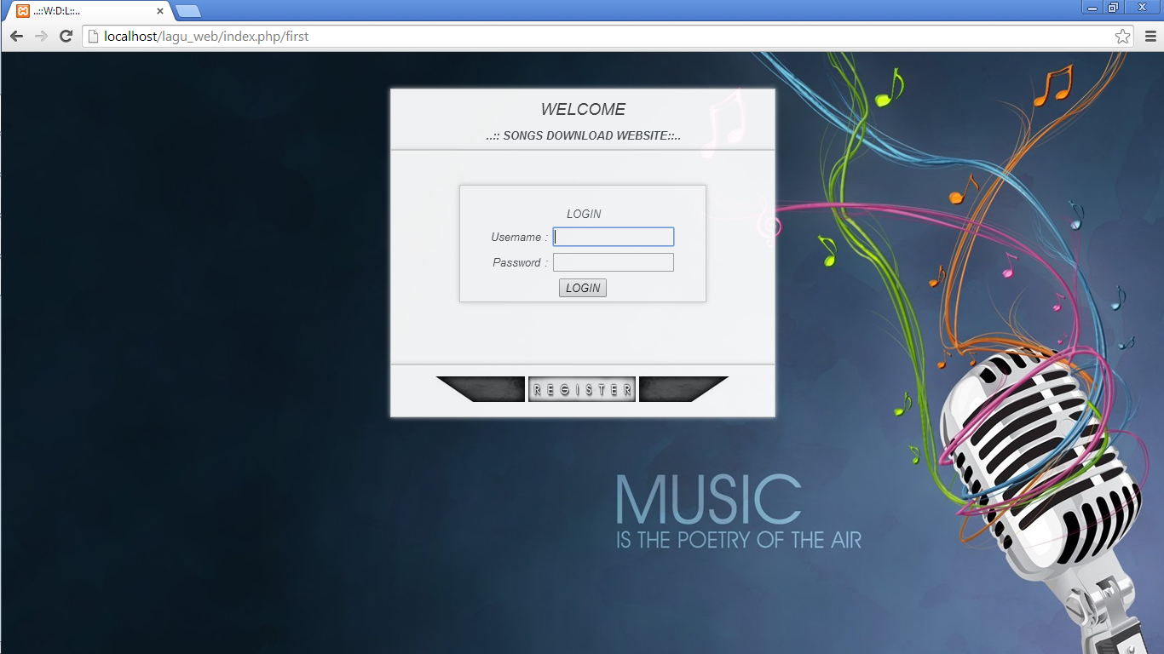

1. Login with sample Admin :

Usename : william

Password : william

1. Then you will be directed to Admin Home page,

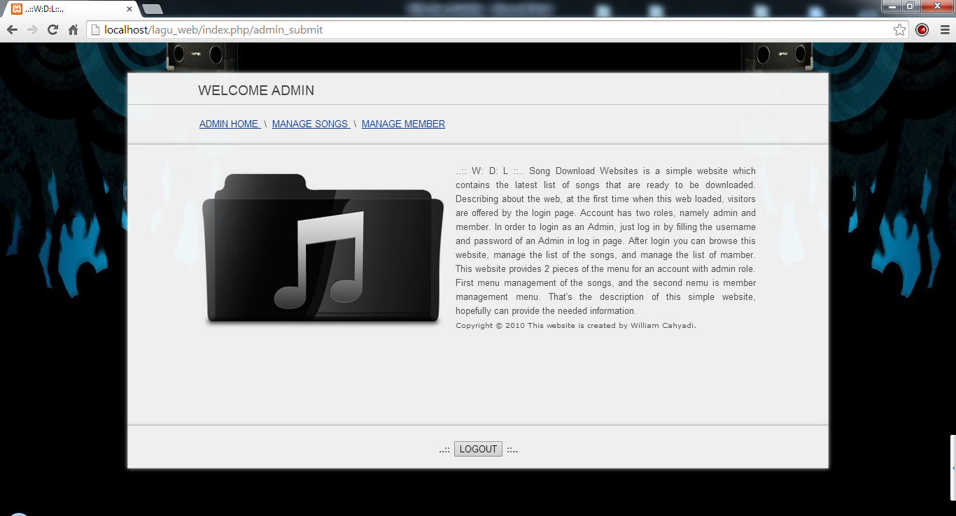

1. There are 3 menu links in Admin Home page:
2. Admin Home
3. Manage Song

This menu has 3 function search, add, edit, and delete list of songs.

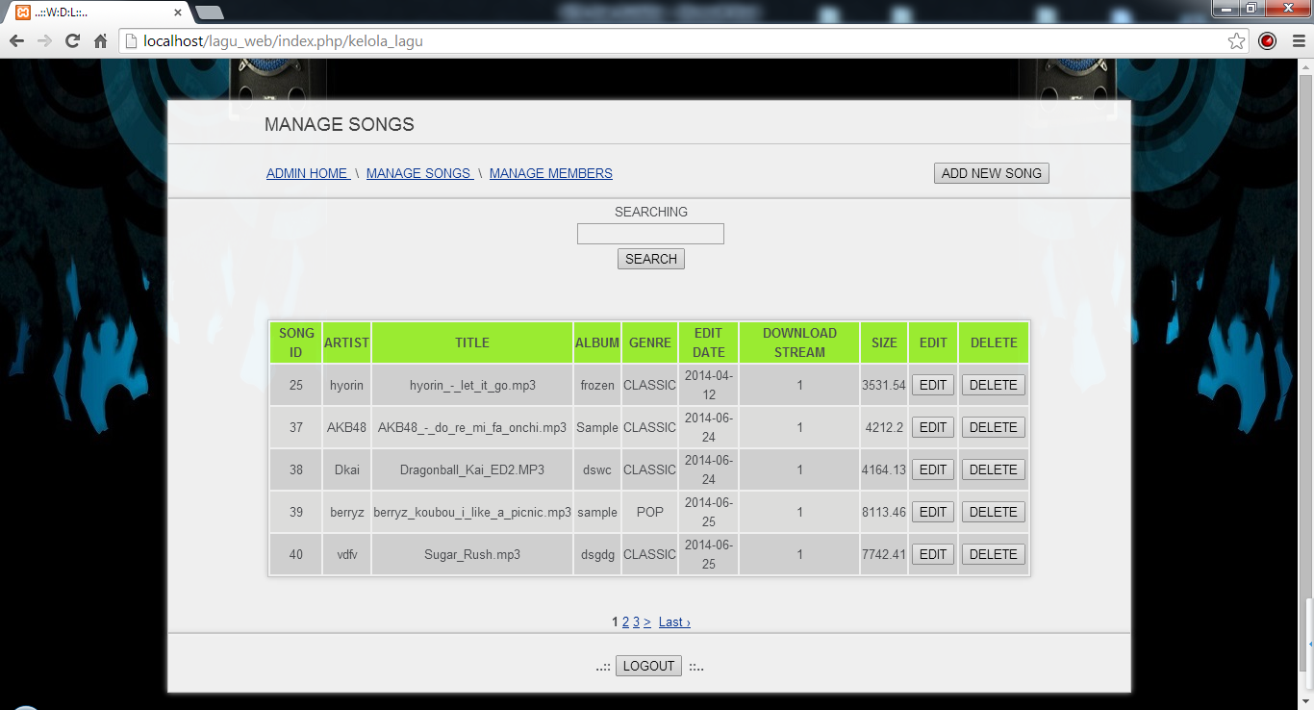

To add new song and will be directed to add new song page.

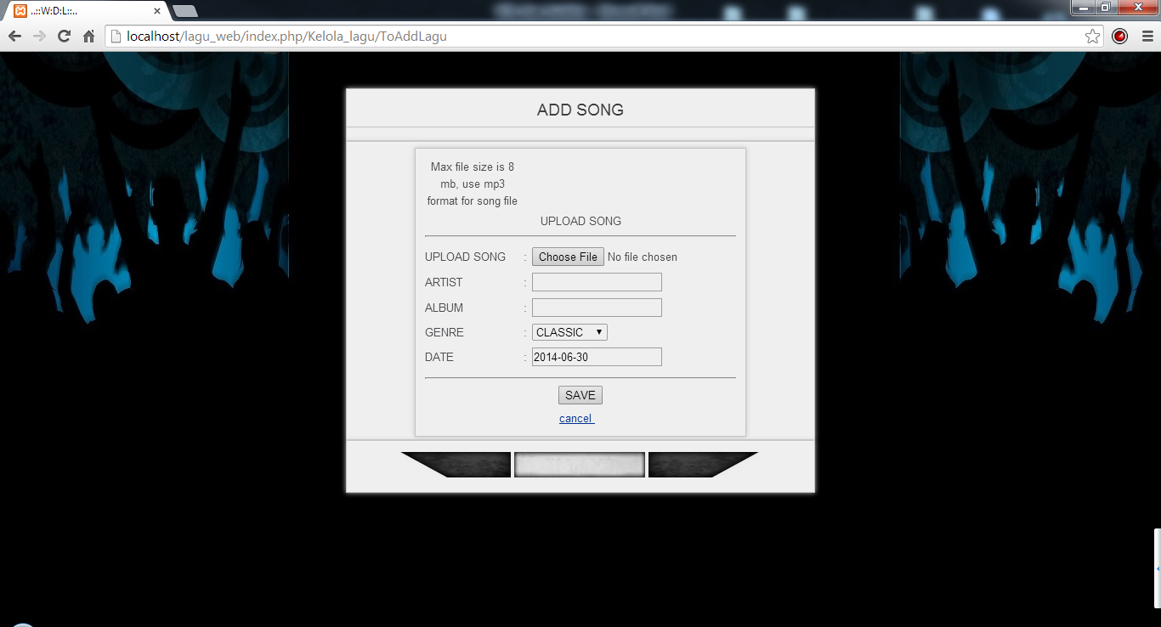

To edit song will be directed to adit song page.

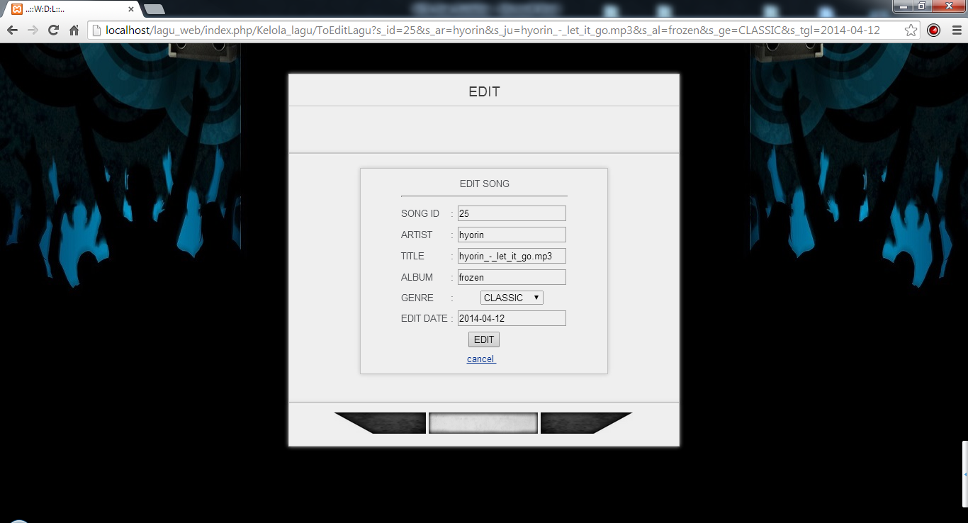

Delete song and will be directed to delete song page.

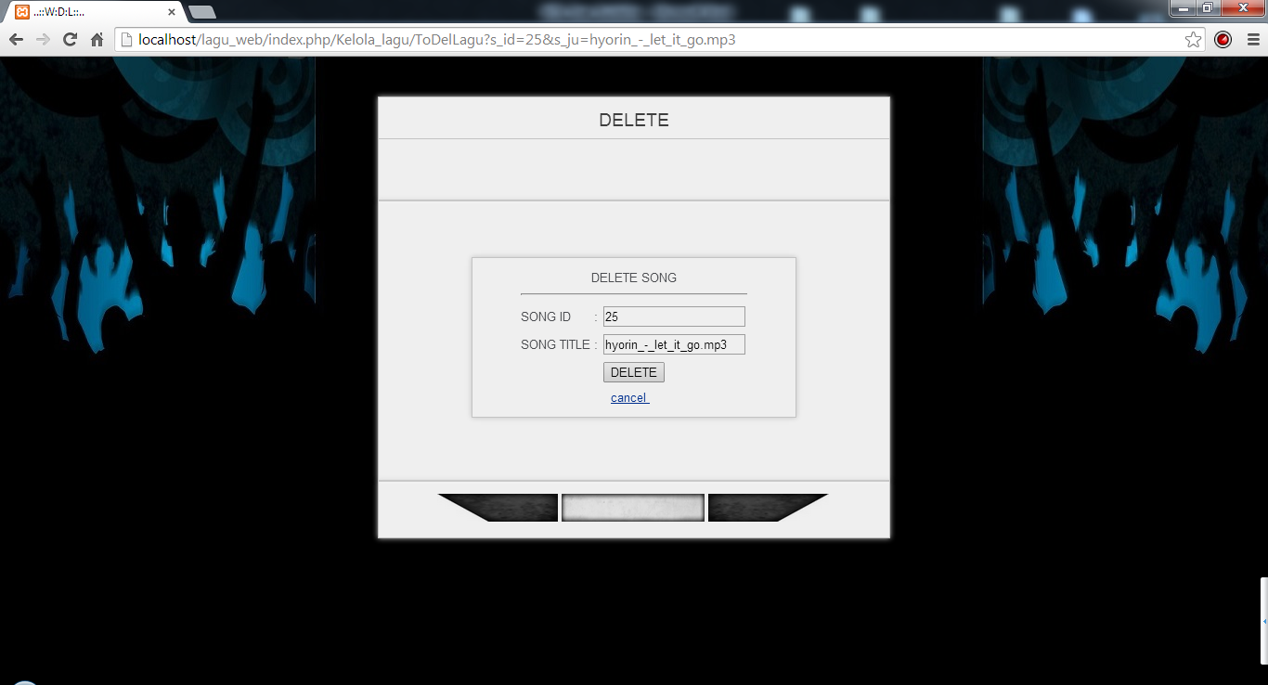

1. Manage Member

This menu has 3 function search, edit, and delete list of members.

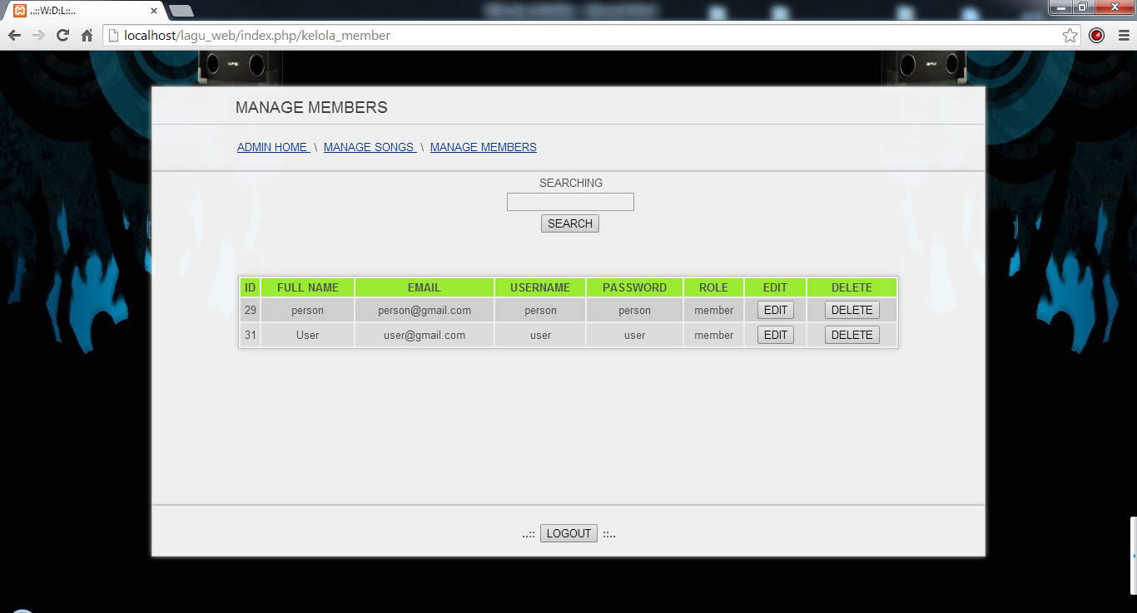

To edit member and will be directed to edit member page.

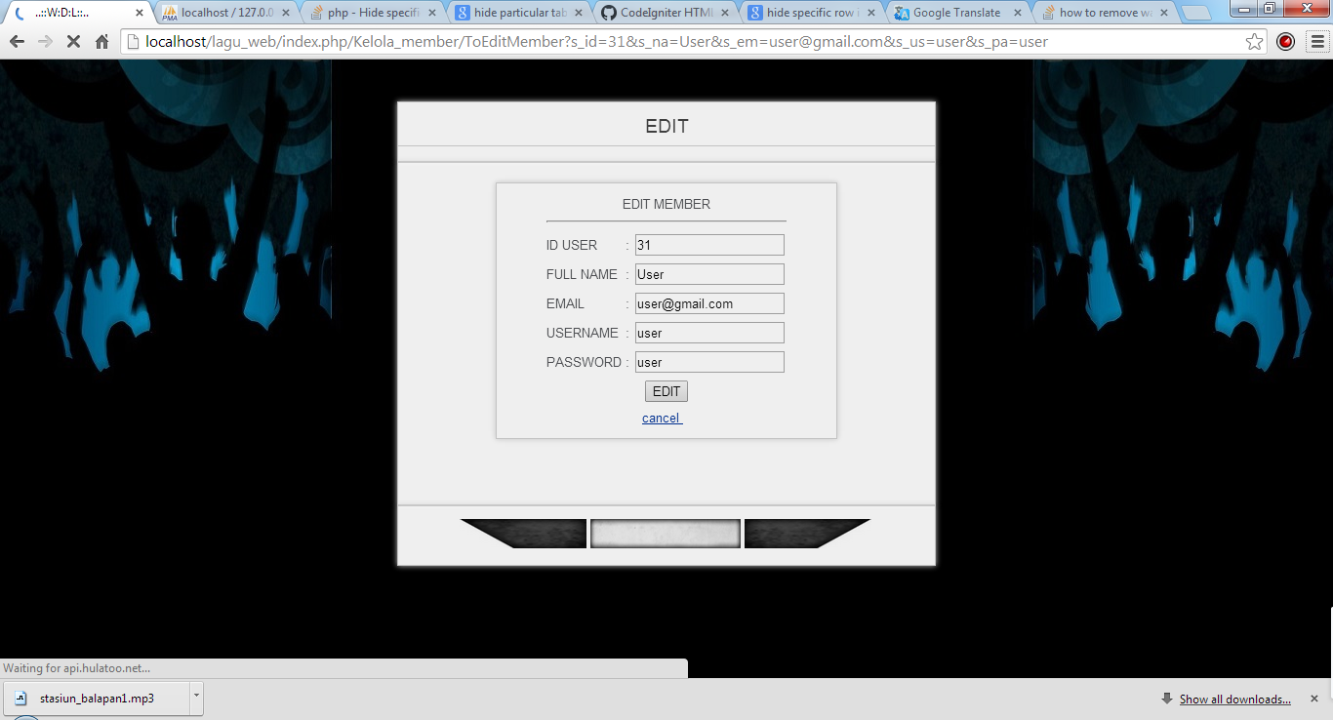

To delete member and will be directed to delete member page.

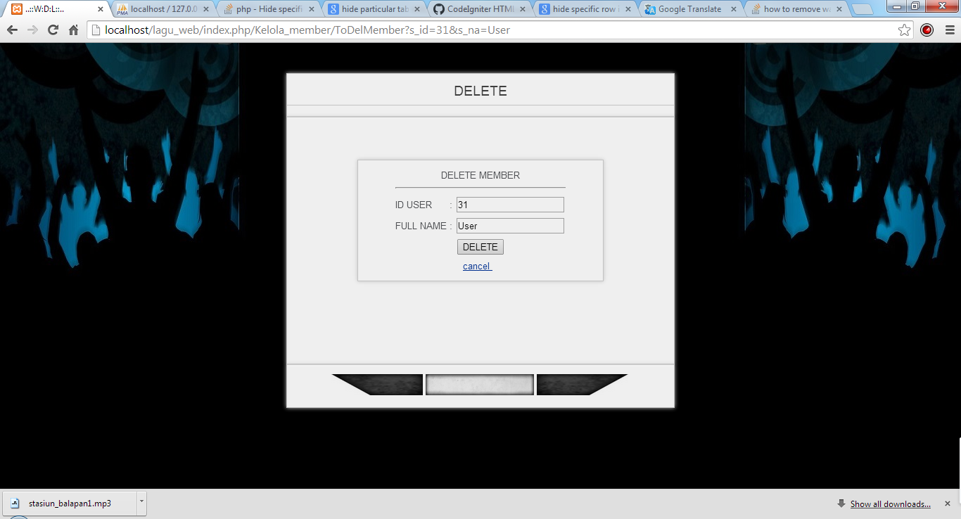

1. Then logout to login as a member.

Login as a sample member :

Username : user

Password : user

1. After login you will be directed to Member Home page.

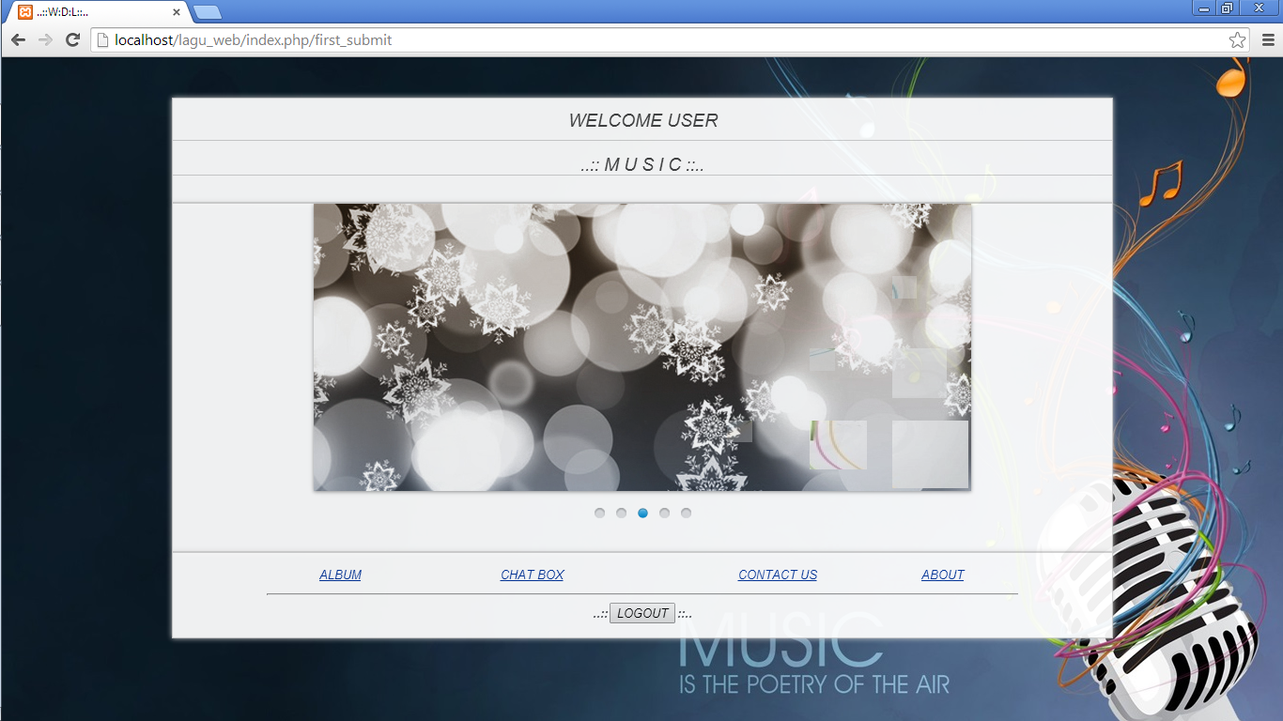

1. You can also register to create your own account in login page by click register, then you will be directed to Register page.

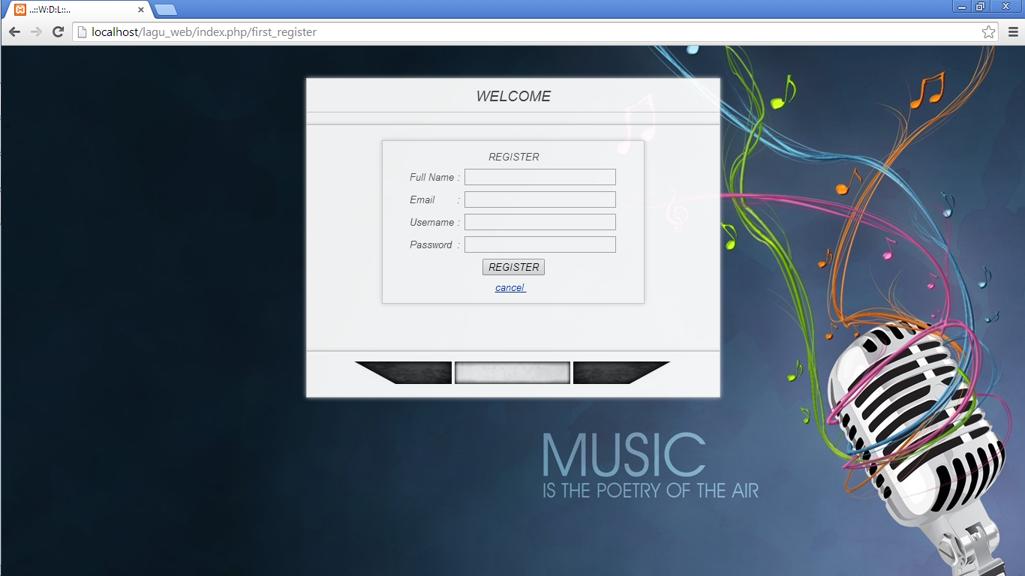

1. After registration success you will directed back to login page the you can login with your username and password.
2. There are 4 menu links in Member Home page :
3. Album

This menu has 3 function search, download song, and view or listen to the song.

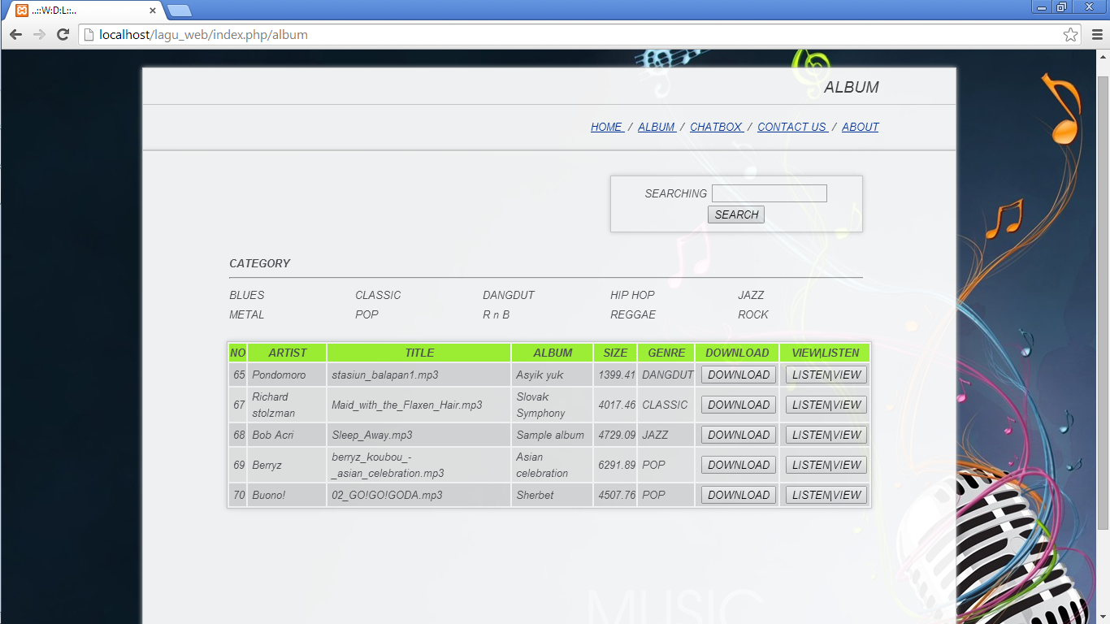

1. Chatbox

This menu has a function to insert chat.

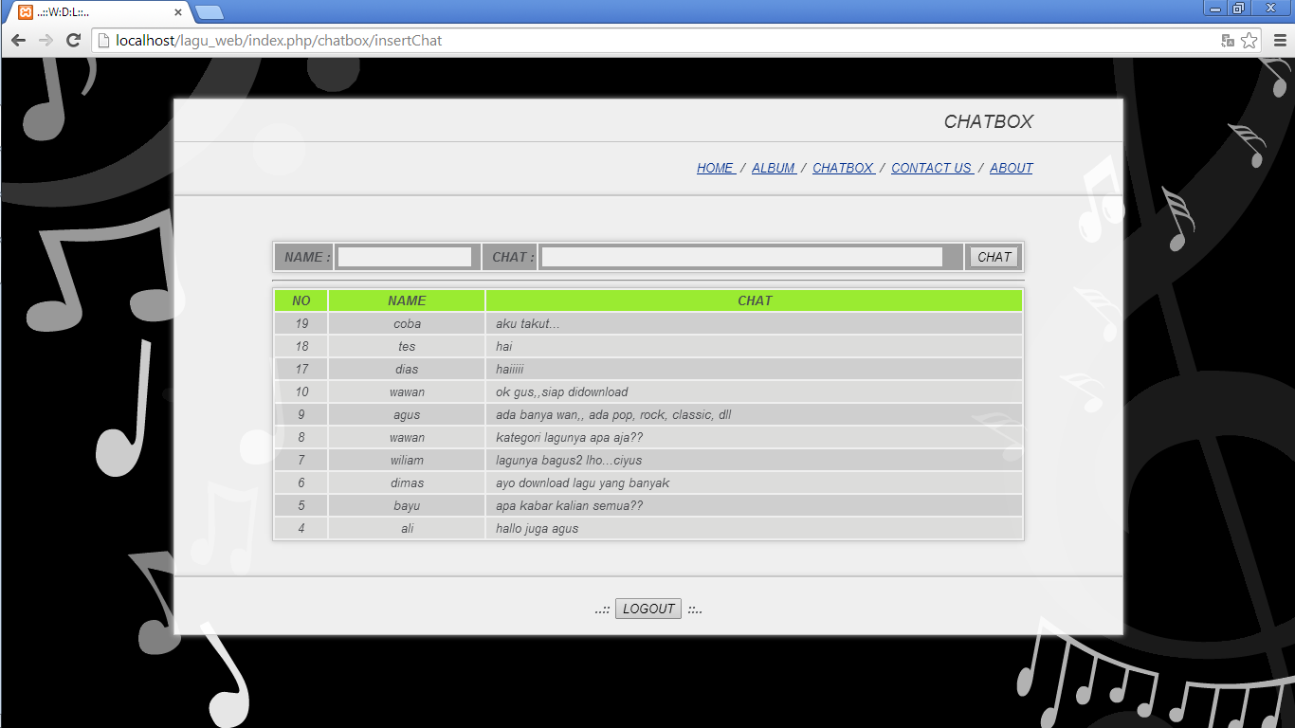

1. Contact Us

This menu has a function to send an email to Admin.

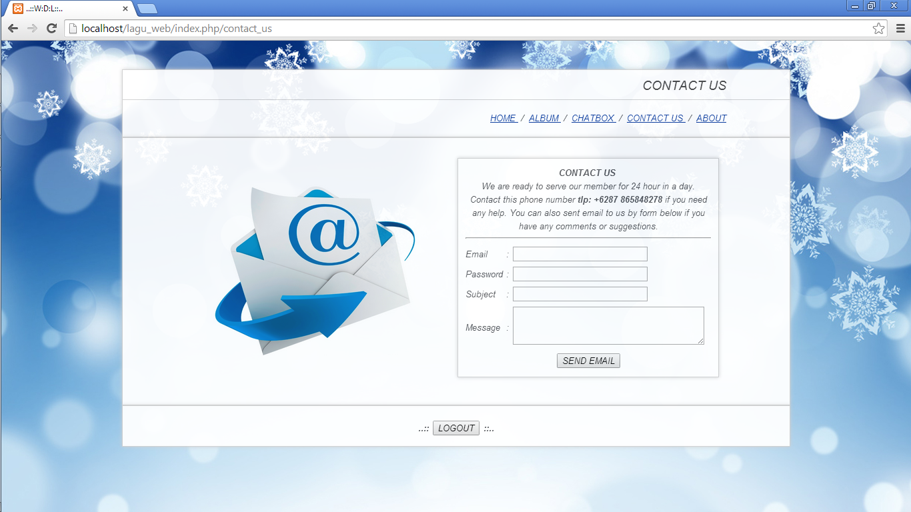

1. About

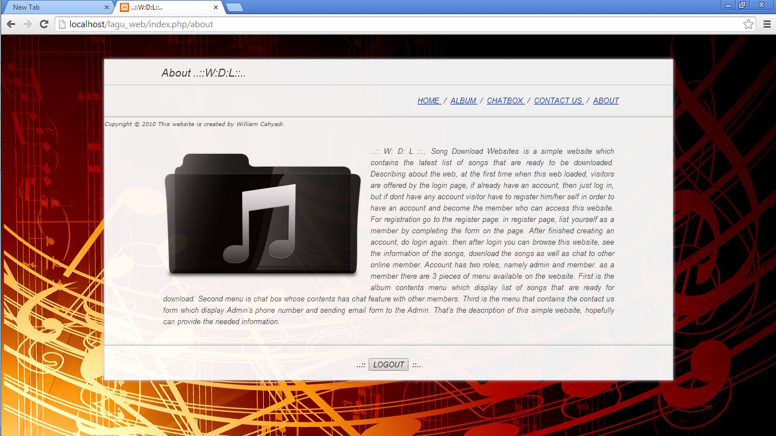

**Web Functions Guide for Admin**

1. **Login**

Fill username and password field in login page with admin account then click login button. Sample account is username : william, password : william

username and password field is required.

1. **Add new song**

Browse file which wanted to be uploaded, Fill artist, title, album, genre,and date field and click save button. All field is required.

1. **Edit new song**

Edit any field of song attribute then click edit.

1. **Delete song**

Confirm data song you want to delete and click delete.

1. **Edit member**

Edit any field of member attribute then click edit.

1. **Delete member**

Confirm data member you want to delete and click delete.

1. **Logout**

Click logout button.

**Web Functions Guide for Member**

1. **Register**

Click button register in login page and in register page fill all fields then click register. Then your member account is created. All fields is required.

1. **Login**

Fill username and password field in login page with member account that has been created or login with sample account (username : user, password : user) then click login button. Username and password field is required.

1. **Download song**

Search song which want to be downloaded then click download button.

1. **Streaming/Listening to the Song**

Direct Stream selected song online.

1. **Insert chat**

Fill name and chat field then click chat button. name and chat field is required.

1. **Send email**

Fill email id, password, subject, and message field then click send email. email id and password field is required.

1. **Logout**

Click logout button.

**Extra**

You can also manage database in table lagu_db in the following url : <http://localhost/phpmyadmin/>

But please manage it wisely.